O
Object oriented analysis and design with java assignment
Integration Testing

Botswana Accountancy College
Cse24-106

Integration Test
This is a test that will be done on the banking system to ensure that the GUI, Controllers, Model and File handler all work correctly together as a whole.

User Logs In:
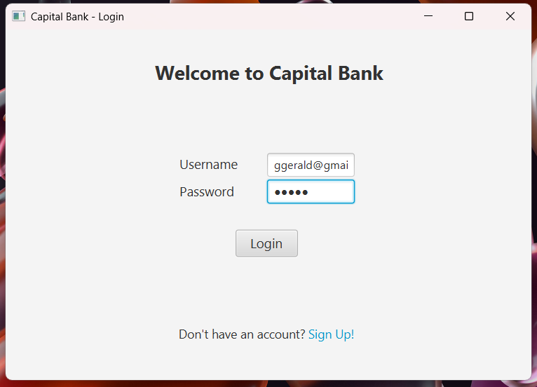
To Login the customer uses their email address or customer ID depending on is they are an individual customer or organization to login to the system.

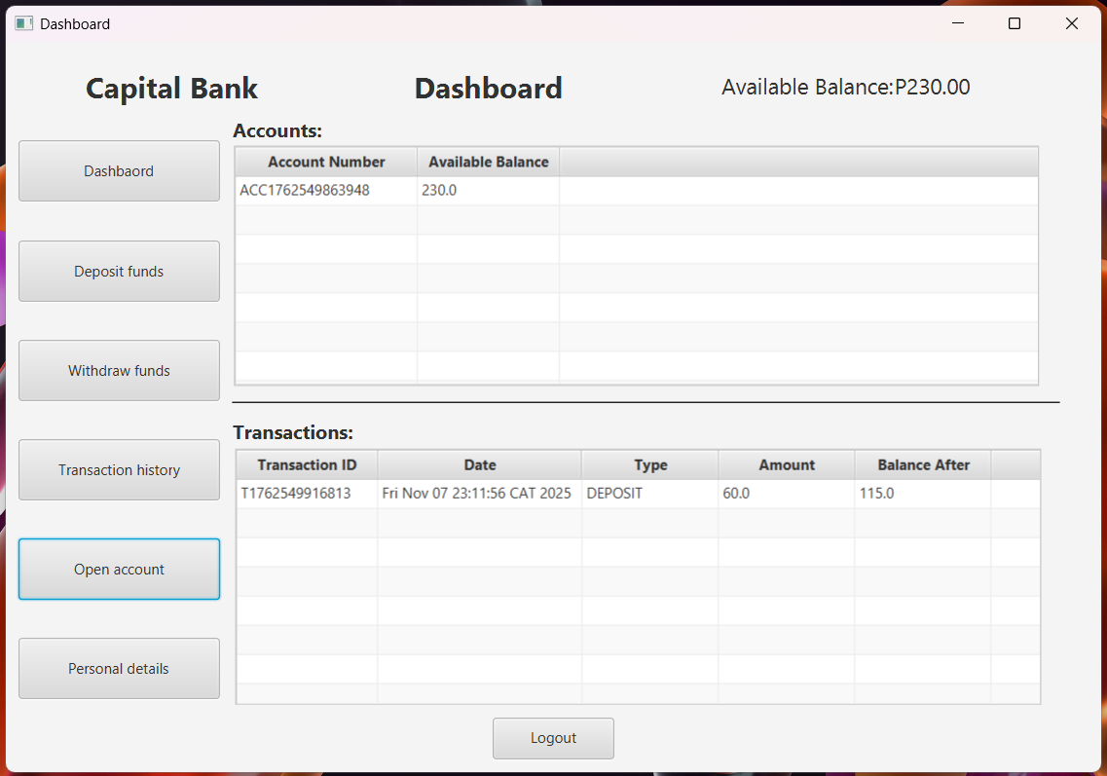
Once logged in the customer is then able to see their Dashboard screen that shows their accounts and transactions that have occurred.

Opening a new account:

Making a Deposit:
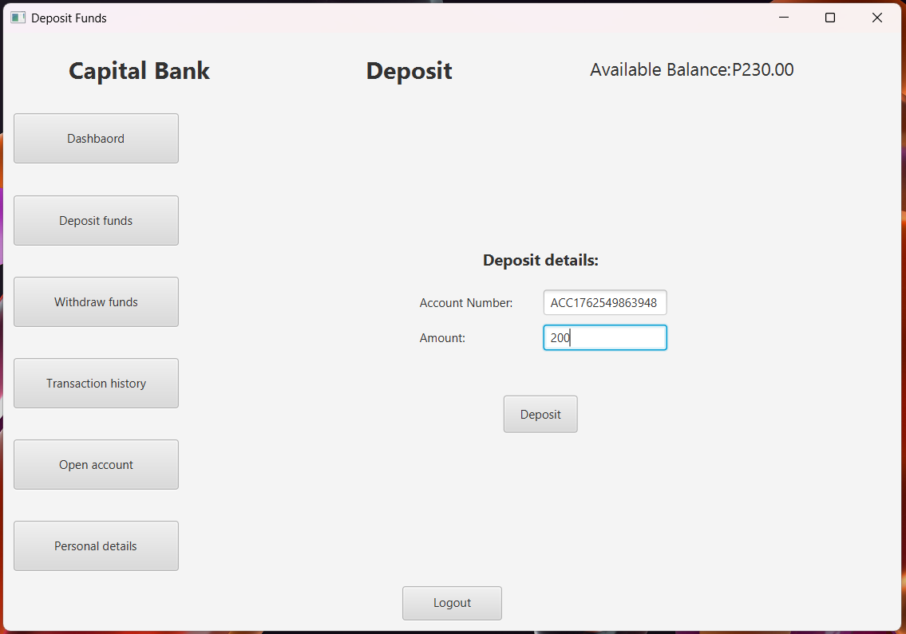
When making a deposit the customer first enters the account number for the respective account they want to open, then enter the amount to be deposited.
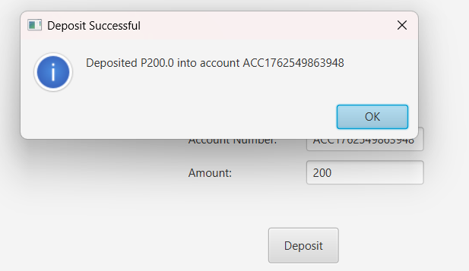
After clicking deposit the system shows the customer the deposit details and the database is immediately updated.
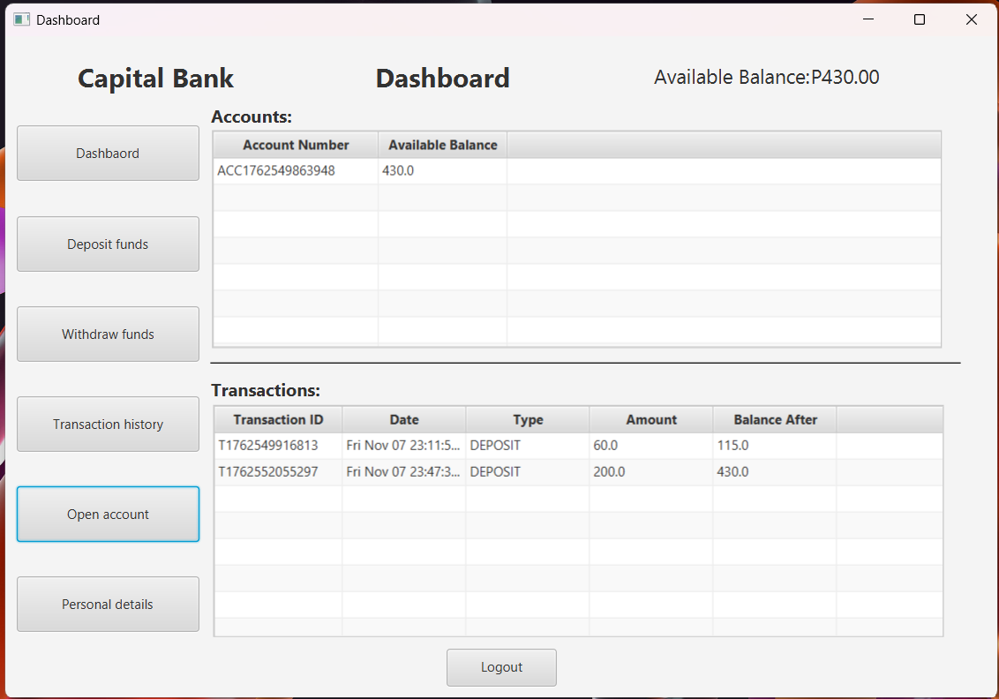

Making a Withdrawal:
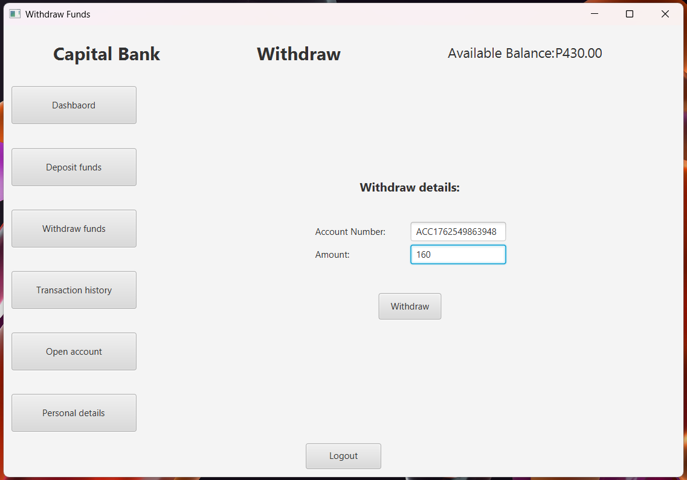
When making a withdrawal the customer first enters the account number of the account, then enters the amount to be withdrawn from that account. 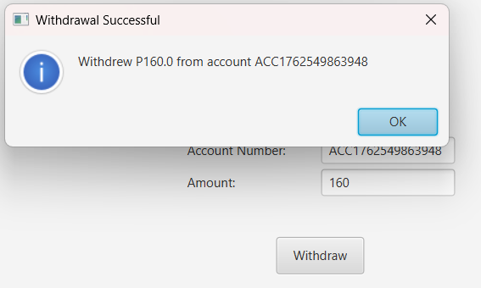
After clicking Withdraw the system shows the customer the withdraw details and the database is immediately updated.
